|  |  |
| --- | --- |
| **Overview of Beximco Pharmaceuticals Ltd.** | Habiba Akter Keya  Batch:41  Roll:01-041-24  Submit Date:07/12/24 |

Contents

Beximco Pharmaceuticals Ltd. 2

2

1 Executive Summary: 2

2 Product and Services: 2

2.1 Hyperlink of the Business 3

2.2 Product and Service process in a SmartArt 3

3 Business Plan: 5

3.1 Company's strengths 5

3.2 Market Analysis 5

3.2.1 **Target Market**: 5

3.2.2 **Competitive Landscape**: 5

BEXIMCO

3.3 Operations and Management 6

3.3.1 **Manufacturing Facilities**: 6

3.3.2 **Research and Development (R&D)**: 6

3.4 Financial Projections 6

3.4.1 **Revenue Streams**: 6

3.4.2 **Projected Growth**: 6

3.4.3 **Funding Requirements**: 6

3.5 SWOT Analysis 6

3.5.1 **Strengths**: 6

3.5.2 **Weaknesses**: 6

3.5.3 **Opportunities**: 6

3.5.4 **Threats**: 6

3.6 This plan will be shown by using a Flow Chart in the followings: 7

4 Sales and cost statistics 8

4.1 Sales & Cost in a table 8

4.2 Sales & Cost in a chart 8

# Beximco Pharmaceuticals Ltd.

# 

# **Executive Summary:**

Beximco Pharmaceuticals Ltd. (Beximco Pharma) is an emerging generic drug player committed to providing access to affordable medicines. Company’s state-of-the-art manufacturing facilities have been accredited by the regulatory authorities of USA, Australia, European Union, Canada, and Brazil, among others, and it currently focuses on building presence in many emerging and developed markets around the world.

Beximco Pharma is consistently building upon its portfolio and currently producing more than 500 products encompassing broad therapeutic categories and the Company has created strong differentiation by offering a range of high-tech, specialized products which are difficult to imitate.

BEXIMCO

# **Product and Services:**

Beximco Pharma currently produces more than 300 generic medicines which are available in well over 500 different presentations and the broad portfolio encompasses all key therapeutic categories including antibiotics, analgesics, anti-diabetic, respiratory, cardiovascular, central nervous system, dermatology, gastrointestinal etc.

Many of its brands remain consistent leaders in their respective therapeutic categories and the company continuously reviews and expands this portfolio in order to ensure that people have access to newer generics, and better treatment options at affordable cost.

With our diverse product range, we are able to respond to the increasing needs of physicians, patients, and health care providers -- both therapeutically and economically.

The Safety of our products and health & well-being of our patients continues to be our Highest Priority. For Medical Information, Product Complaint or Reporting of an Adverse Event involving Beximco Pharma Product please contact:

In the United States:

(877) 372-6093 (Monday – Friday 8am – 6pm Central Time GMT-6)

(866) 578-4617

DrugSafety@propharmagroup.com

Outside the United States:

+8802-9664449

+8802-9664449

pharmacovigilance@bpl.net

## Hyperlink of the Business

- [Beximco Pharmaceuticals Ltd.](https://beximcopharma.com/products)

## Product and Service process in a SmartArt

**Products of Beximco Pharma Ltd**

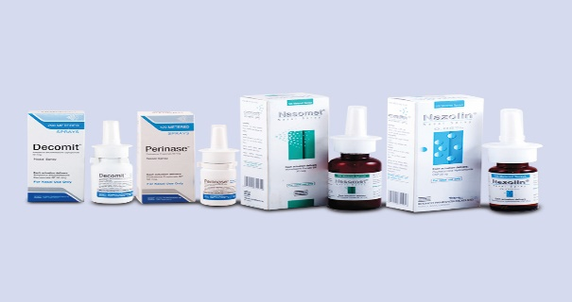

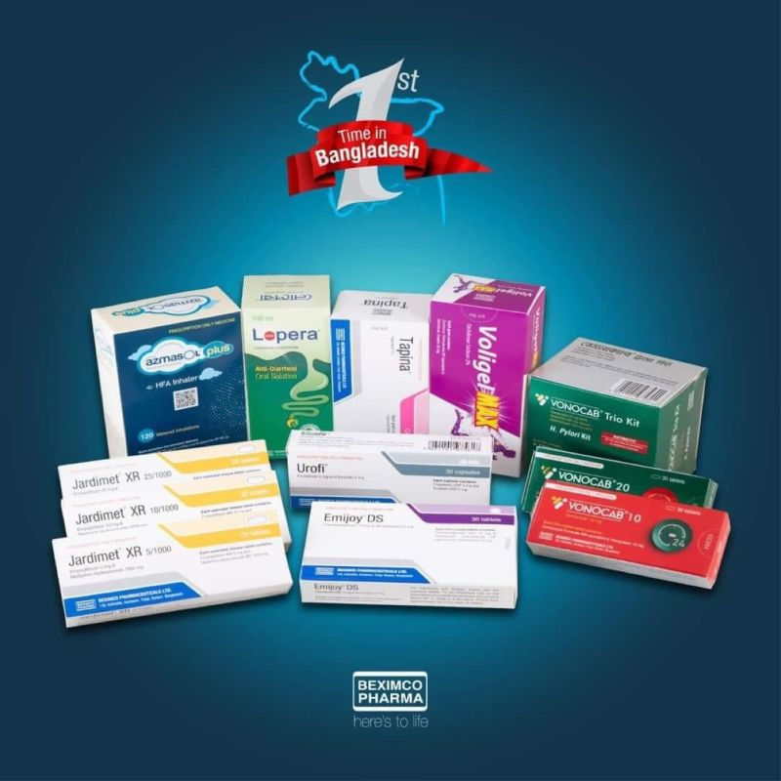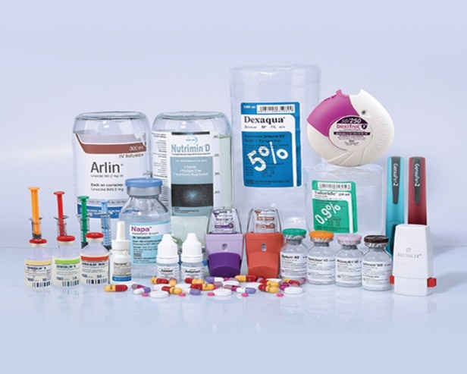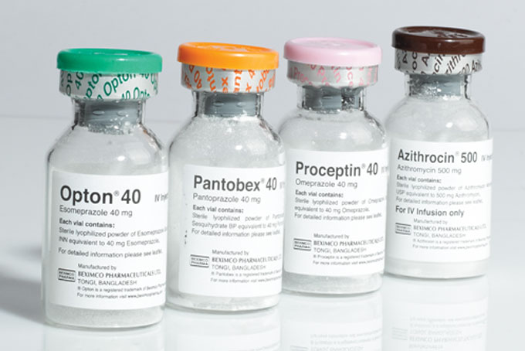

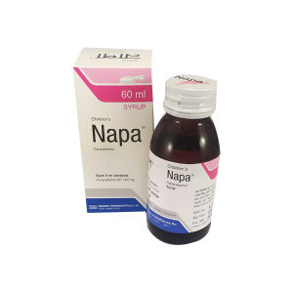

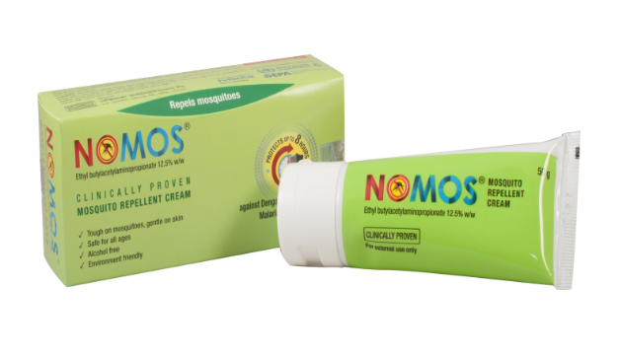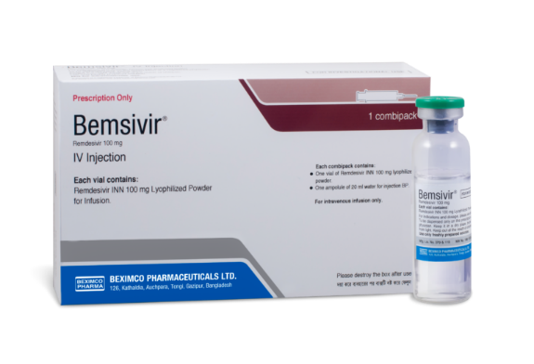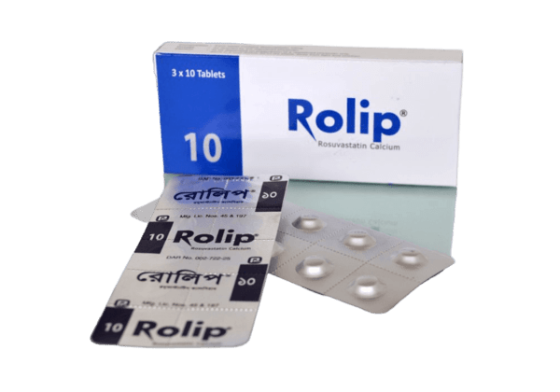

# Business Plan:

Beximco Pharmaceuticals Ltd.'s business plan is centered around the following goals:

•**Mission**

Improve human health and well-being by providing affordable and modern medicines that meet global quality standards

•**Vision**

Become a successful, trusted, and admired pharmaceutical company in the region by strengthening research and development, creating partnerships, and building a global presence

•**Core values**

Commitment to quality, customer satisfaction, people focus, and accountability

BEXIMCO

## Company's strengths

•**Cost advantages**

The average wage in Bangladesh is lower than in China or India, which can lead to cost advantages for manufacturers

•**Professionalism**

Beximco Pharma has a track record of professionalism and adheres to international standards

•**Partnerships**

Beximco Pharma has established partnerships with leading pharmaceutical companies, such as GlaxoSmithKline (GSK).

## ****Market Analysis****

### **Target Market**:

* + Domestic Market: Hospitals, clinics, and pharmacies in Bangladesh.
  + Export Markets: Europe, the USA, Asia-Pacific, and Africa.

### **Competitive Landscape**:

* + Competitors: Square Pharmaceuticals, Renata Limited, Incepta Pharmaceuticals, etc.
  + BPL's Competitive Advantage: State-of-the-art facilities, WHO cGMP compliance, and a strong international presence.

## ****Operations and Management****

### **Manufacturing Facilities**:

* + Facilities are WHO cGMP-compliant and export-oriented.
  + Incorporate cutting-edge technology and automation.

### **Research and Development (R&D)**:

* + Investments in R&D to develop new formulations and drug delivery systems.
  + Partnerships with global research organizations for innovation.

## ****Financial Projections****

### **Revenue Streams**:

* + Domestic sales (~60%)
  + Export revenue (~40%)

### **Projected Growth**:

BEXIMCO

* + CAGR of 10-12% over the next five years due to expanded product offerings and market penetration.

### **Funding Requirements**:

* + Investment in R&D and new production facilities.
  + Expansion into new regulated markets.

## ****SWOT Analysis****

### **Strengths**:

* + Strong brand reputation.
  + Advanced manufacturing facilities.
  + Wide product portfolio.

### **Weaknesses**:

* + High dependency on generic products.
  + Regulatory challenges in international markets.

### **Opportunities**:

* + Growth in emerging markets.
  + Expanding demand for biosimilars.

### **Threats**:

* + Intense competition.
  + Price pressures in generic markets.

## This plan will be shown by using a Flow Chart in the followings:

Analyze Market

Develop Product

Identify Gaps

Regulatory Approval

Manufacture Product

Launch Marketing Strategy

Monitor Sales

Evaluate Financials

Implement Risk Mitigation

**Yes**

No

# Sales and cost statistics

## Sales & Cost in a table

|  |  |  |  |
| --- | --- | --- | --- |
| **Year** | **Sales** | **Expenses** | **Profit** |
| 2023 | 39267 | 30295 | 8972 |
| 2022 | 34669 | 26447 | 8222 |
| 2021 | 29494 | 22041 | 7453 |

## Sales & Cost in a chart

***The End***

***The End***